***Region 5 Adult Education Class Credit Card Payments using MySchoolBucks***

Scan the QR code below:

Or use the link below:

<https://www.myschoolbucks.com/ver2/prdembd?ref=ZZHAE44DCD00FYE_ZZ5ZPM832XNO176>

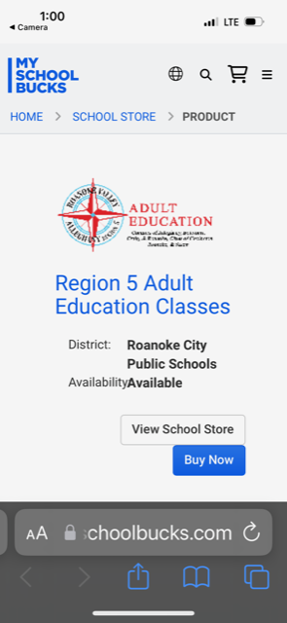

Choose Buy Now

Complete the form and choose **Buy Now** (If you choose Add to Cart, you can select additional options)

At this point, you have several options.

* If you have a MySchoolBucks account, you can login here.
* If you don’t have an account, you can create one **by clicking Register Now**.
* Or you can choose Checkout as Guest.

Validate your information and complete the credit card information.

**You will receive a confirmation after your order is complete.**